**Case Study using below UI technologies**

* HTML5
* CSS3
* JavaScript
* Web Storage

**Note:**

**Application Name: Online Telephone Directory**

**Description:**

**The user can use this application to maintain online phonebook.**

**The user can register an account in the system. Once He register he can get an account with the credentials.**

**With that credentials, the user can login and view his info.**

**At any moment the user can view and edit his account info.**

**Once the user login into the system, he/she can add/remove contacts to his phone book.**

**User can view his contacts.**

**User can edit contacts**

**User can delete contacts.**

**Roles:**

**User Role**

**Admin Role**

**Task: UI Layer**

**Create a Standard Layout which can be shared across the views.**

**Layout includes header, footer, sidebar and content section.**

**Include navigation section in the header, so that the user can navigate across the views using hyperlinks.**

**You can use HTML 5 semantic elements and CSS3 styles for better UX.**

**Include: Home, Contacts, about links in the navigation section.**

**When the start page (index.html) page is loaded, you must display**

**[Welcome, Guest!][Login/Register] on the top right of the page.**

**So that, you use can Login with the existing account. Or the user can create a new Account.**

**When the user clicks on the Login link, login.html view must be loaded.**

**When the user clicks on the Register, Register.html view must be loaded.**

**User Role:**

**If the user login to the system using existing account, you must display**

**[Welcome Username!] [Logout] on the top right of the page.**

**And you must enable some links like View Details, Edit/Update Details, and Reset Password links in the sidebar section.**

**For View Details, you must display the UserInfo for readonly.**

**For Edit/Update, you must able to edit and update the user info.**

**For Reset Password, you must able to reset the current password with new password.**

**The User can add contacts to the Phonebook, edit contact in the phone book, remove the contact from the phonebook and can search for contact info from phonebook based on the firstname or lastname or mobile number.**

**Admin Role:**

**If the Admin Login to the System, The admin can View all Users Info and Can able to remove the Users from the System.**

**Whenever admin removes the User, System has to delete all the User Info and his Phonebook.**

**Admin can also view /edit /reset password.**

**Pages:**

**Index.html**

**About.html**

**Contacts.html**

**Login.html**

**Register.html**

**UserInfo.html**

**EditUserInfo.html**

**ResetPassword.html**

**Signout.html**

**CreateContact.html**

**EditContact.html**

**ViewDeleteContact.html**

**You need the below fields for JavaScript Array:**

**UserId(autogerated) , Username, Password, Email, Gender, Mobile**

**You need below fields for phonebook**

**ContactId, FirstName, LastName,City,State,Address,Zip,Email,Gender,Mobile,UserId(foreign key)**

Sample Screens:

index.html

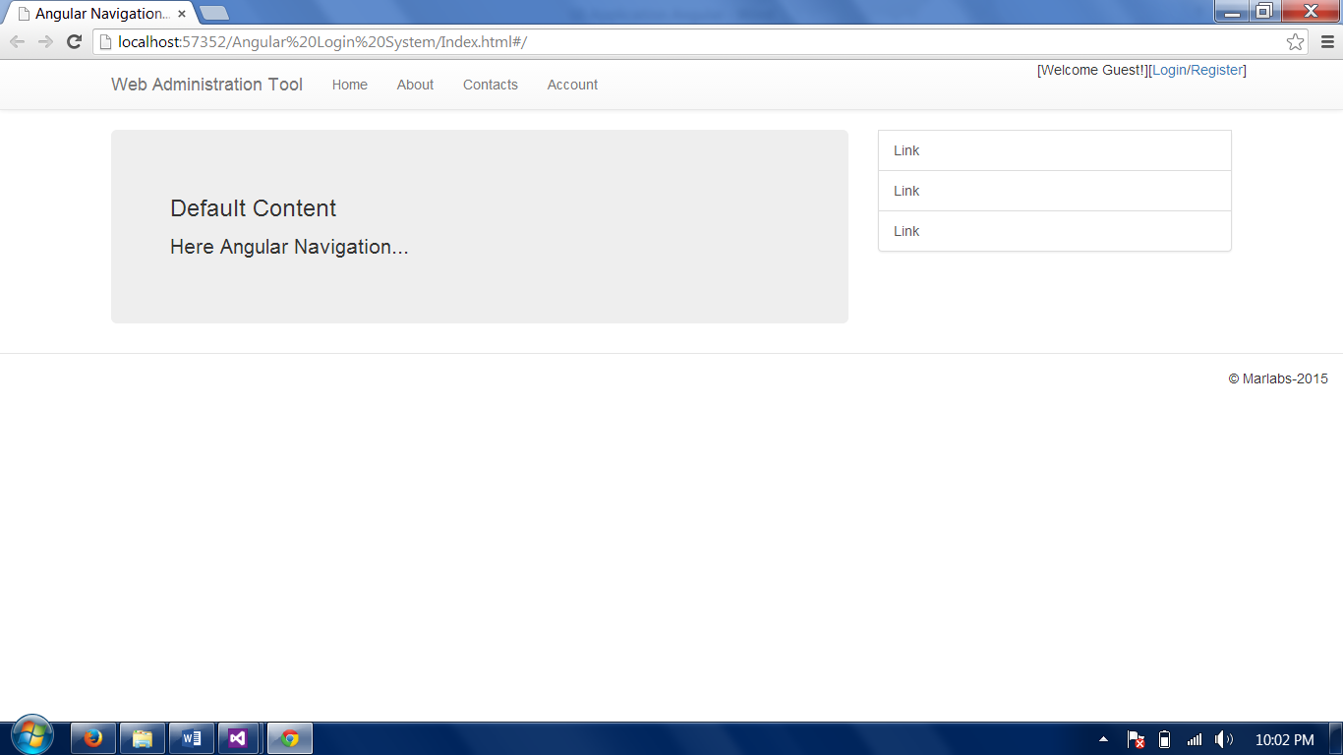

Register.html

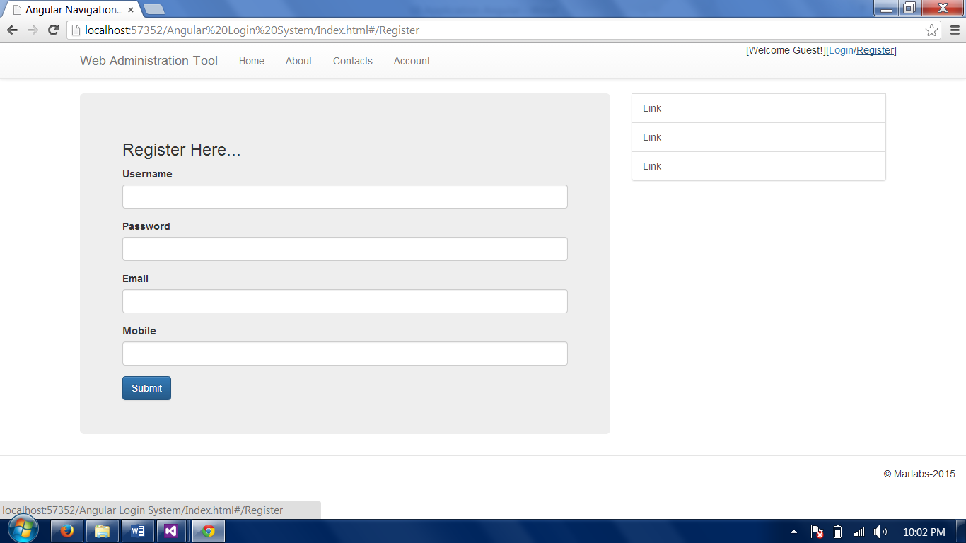

Login:

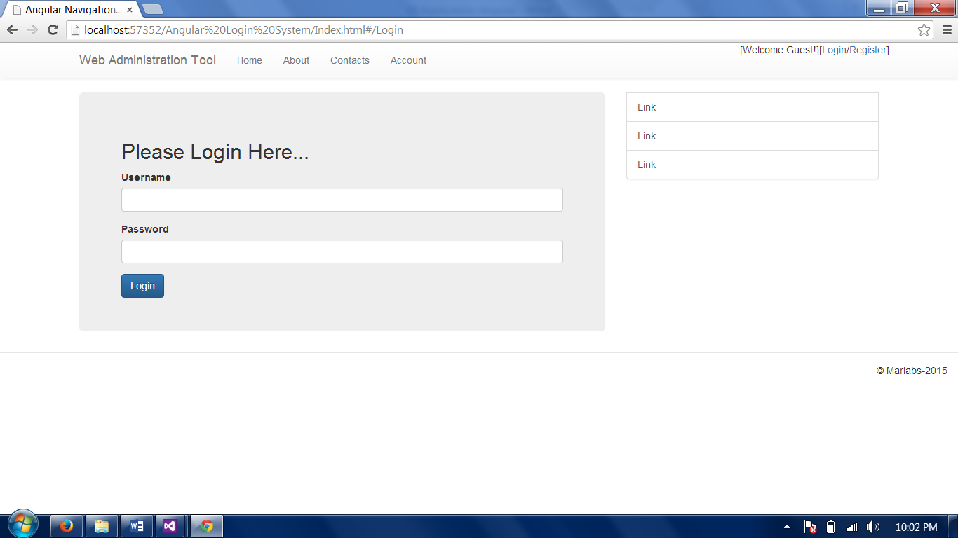

After login:

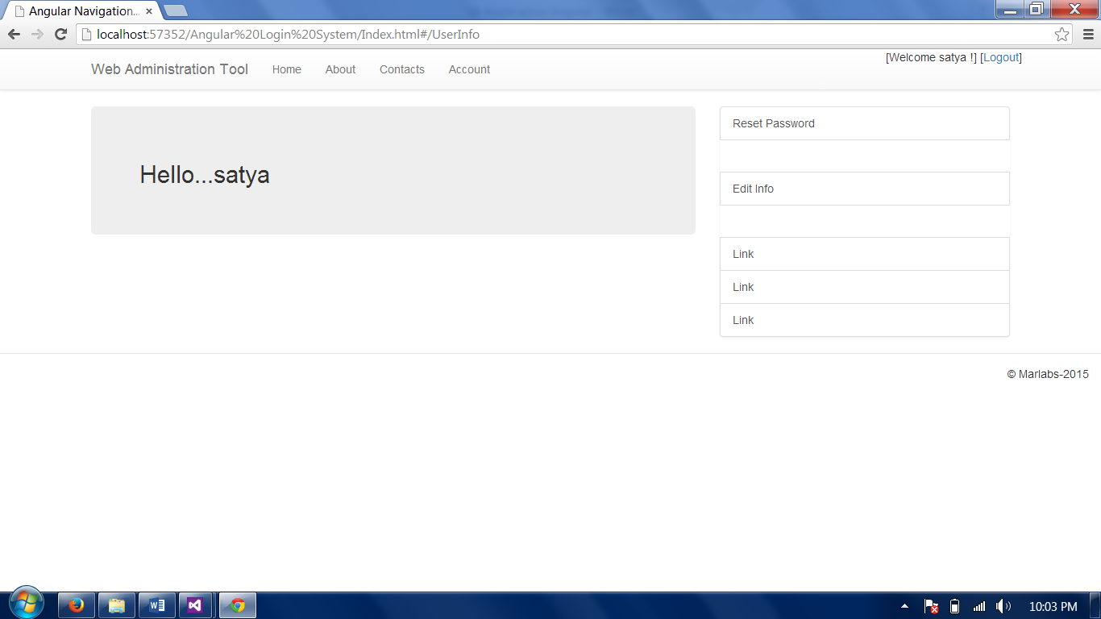

Edit Info:

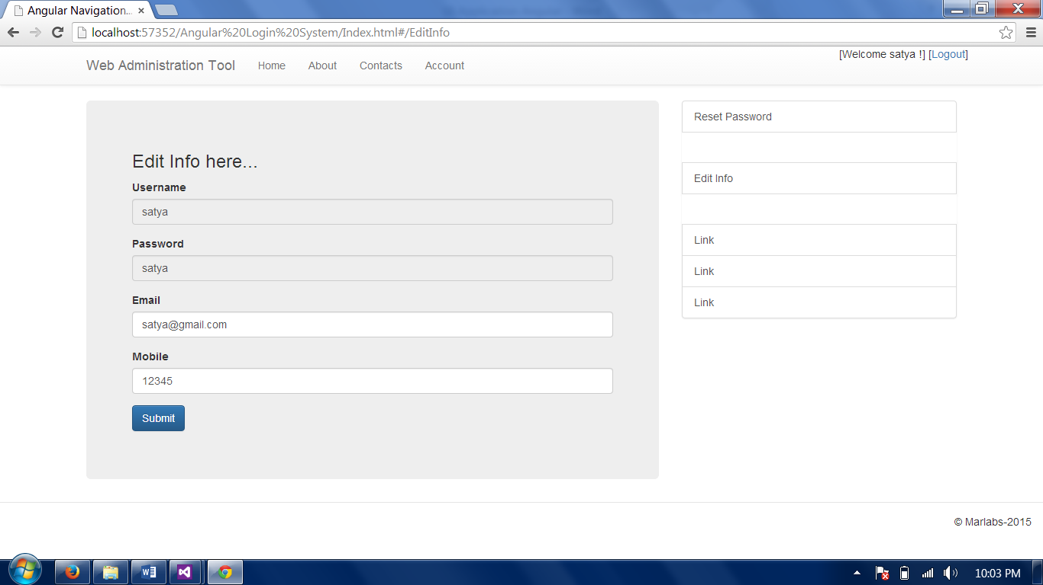

Reset Password:

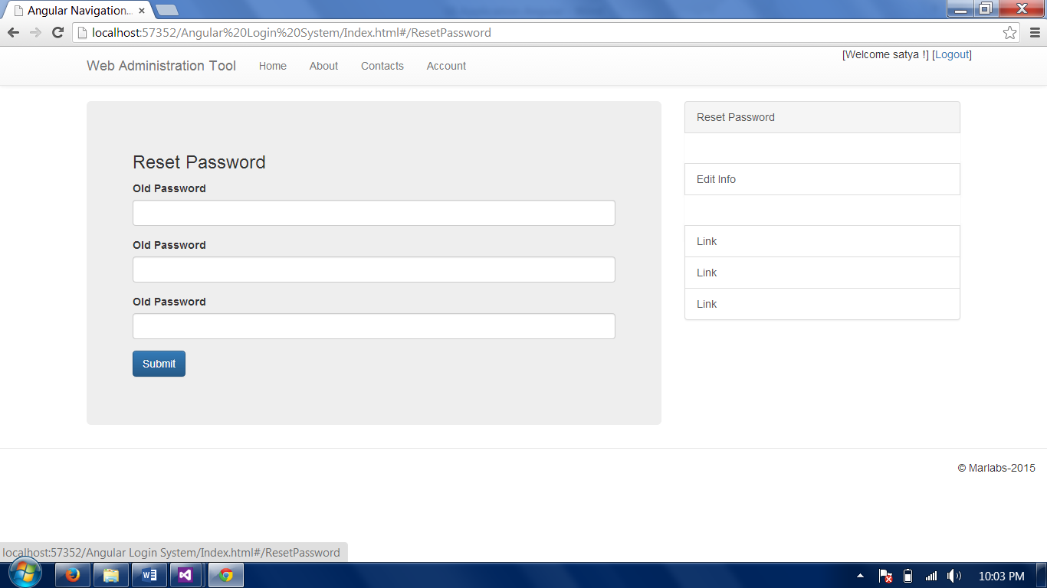

Logoff:



Logoff.html

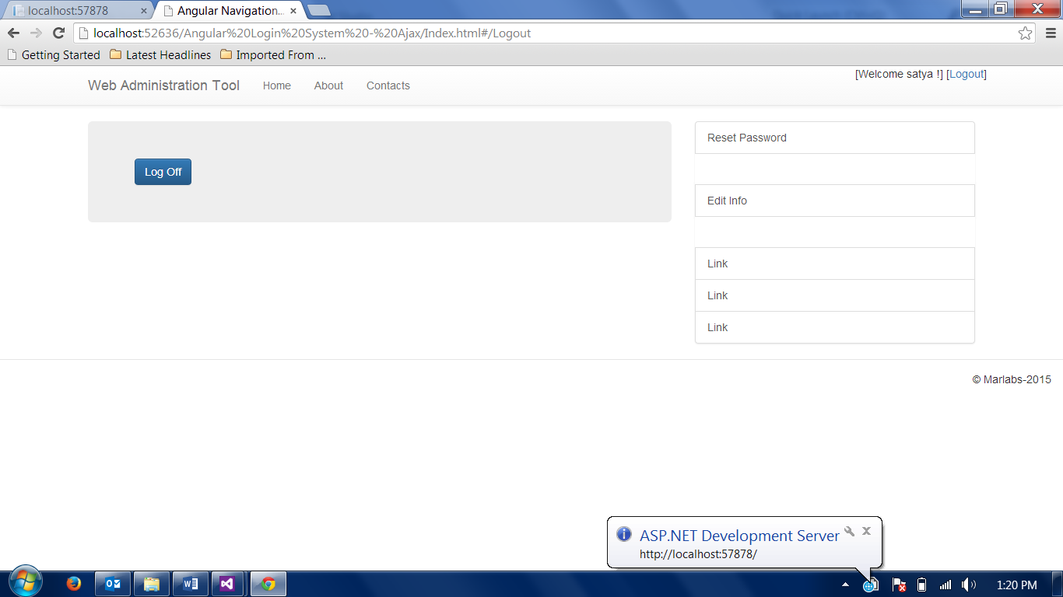

Similar to above forms, you can design the Phone book views